REPORT

Observance of
“World Salt Awareness Week”

2 – 8 February 2009

by

Hypertension Committee of National Heart Foundation of Bangladesh

Plot-7/2, Section-2, Mirpur, Dhaka-1216
Phone: 880-2-8061314-6, 8083935-6
E-mail: nhf@bdonline.com, Fax: 880-2-8016694

Submitted by
Prof. R. K. Khandaker
Vice President, National Heart Foundation of Bangladesh
Chairman, Hypertension Committee of National Heart Foundation of Bangladesh
Member, WASH and ISH

Observance of World Salt Awareness Week 2009 by

Hypertension Committee of National Heart Foundation of Bangladesh

Hypertension Committee of National Heart Foundation of Bangladesh observed the World Salt Awareness Week (WSAW 09) from 2 - 8 February 2009 in a befitting manner as a part of worldwide observance by World Action on Salt and Health (WASH) focusing on salt in food eaten out of the home aiming to raise awareness that foods in restaurants, takeaways, fast foods, street food, canteen food etc can contain a lot of hidden salt. This year’s theme was “Salt and Eating Out”. Observation of WSAW 2009 included a press conference held on 3 February 2009, round table meeting on Salt & Health, and discussion program regarding significance of WSAW 2009 on national radio and televisions. A poster and a brochure on ill effects of high consumption of salt on health and advices on how to take less salt were also published and distributed all over the country.

1. Press Conference:

A meeting with the editors of local newspapers and reporters from different electronic media was held in the conference room of National Press Club on February 3, 2009 to increase the mass awareness. Eminent cardiologists, physicians and public health specialists attended the conference. Prof. R. K. Khandaker, Chairman Hypertension Committee of National Heart Foundation of Bangladesh and Member, World Action on Salt and Health (WASH), highlighted the ill effects of increased consumption of salt on health and described the dreadful consequences of increased trend of eating out to emphasize this year’s theme. He also briefed the salt content of these fast foods, restaurant and processed food items which is several times higher according to different surveys and WHO recommendation. Dr. Sohel Reza Choudhury, a WHO representative, stressed on the control of risk factors for the causation of chronic diseases, specially on hypertension which can be decrease by reducing excess salt intake. He put forward the example of Japanese people, where the mortality rate due to stroke was 10 times higher 40-50 years back, as they used to consume 15-18 gm salt per day and they also used to preserve the food with salt. After that they took policies and created awareness among people; as a result the average salt consumption came down to 10 gm per day now a day which decreased the death rate to 80 percent due to stroke since 1960. He also advised on cutting out the table salt and discontinuing taking extra salt in sautéed form. Prof. KMHS Sirajul Haque, Secretary General of Hypertension Committee of National Heart Foundation of Bangladesh, pointed out that lifestyle modifications and home control can decrease the rate and prevent the diseases related to increased intake of salt. Secretary General of National Heart Foundation of Bangladesh, National Prof. Brig. (Rtd.) Abdul Malik, thanked all the media personnel and drew attention to spread the message towards the general population not to take salt in excess. He also underscored the need for reducing salt intake to possess a good health and to prevent the complications of hypertension. He also quoted that thousands miles journey start with a single step. The press conference came to an end after a question & answer session with the journalists.

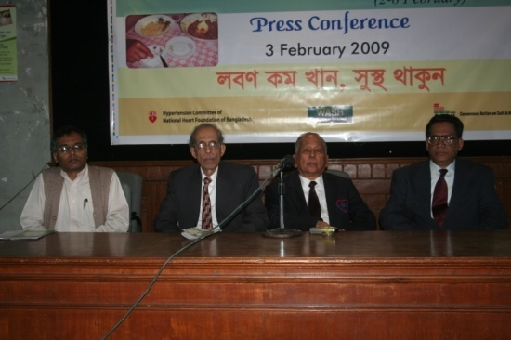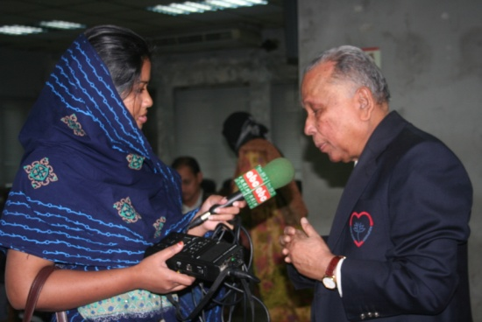

Press Conference on the eve of WSAW 2009

2. Round Table meeting on Salt & Health:

Experts and stake holders such as local leaders, school teachers, representatives from food industries and salt industry, catering business, eminent cardiologists, nephrologists, physicians, nutritionist, NGO personnel, WHO representative and representative from different social organizations were invited to attend the meeting. Prof. R. K. Khandaker, in his welcome speech briefed out the programmes arranged on the eve of World Salt Awareness Week 2009. Dr. Sohel Reza Choudhury, WHO representative, presented the key note paper on reducing salt intake in Bangladeshi population to control high blood pressure. He discussed the current scientific evidences and meta analysis of papers which clearly depicted the association of high blood pressure with high consumption of salt. He also emphasized on WHO recommendations regarding monitoring of salt intake assessment, monitoring and evaluation of policies, programmes & initiatives and stakeholders, self regulation & legislation by government, and labeling & reformulation of products. Data on salt intake is scarce in Bangladesh and population wide approach has to be taken to create mass awareness to reduce salt intake. Development of policies can be initiated by influencing the Government, stakeholders and industry personnel. Experts also stressed on the need to carry out surveys about the exact salt content of people living in tropical countries. Family awareness has to be brought up and restaurants should display ‘no extra salt’ as cautionary message. Massive studies are needed to set out the exact salt consumption of population according to age category, physical condition, disease pattern, living environment and occupation so that a national policy and guideline can be formulated. National Prf. Brig. (Rtd.) Abdul Malik, Chairperson of the round table meeting at the end, addressed hypertension as an emerging health problem for which salt is one of the main factors and this can be prevented at the community level very easily by the health workers and media hype. The round table meeting finished off with question and answer session followed by light refreshment.

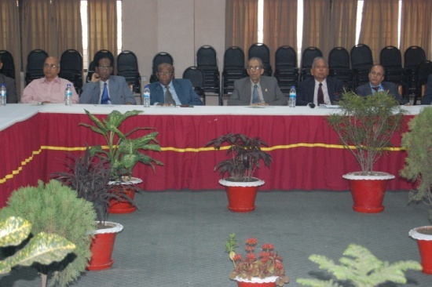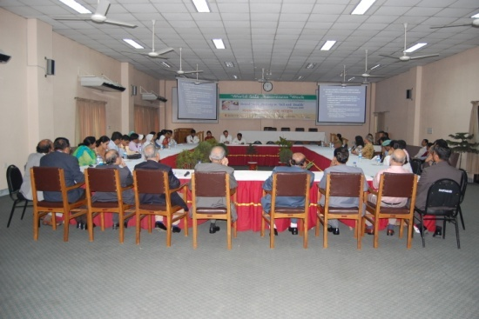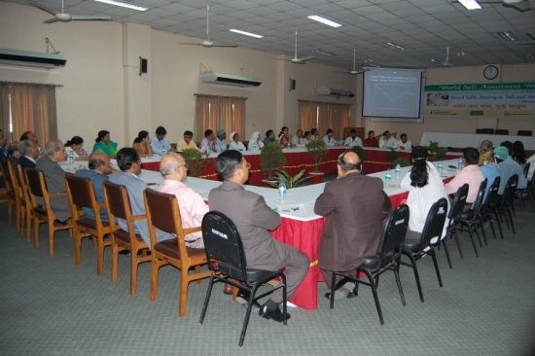

Round Table meeting on Salt & Health

3. Poster and Brochure development and distribution:

A poster and brochure carrying the messages of ill effects of excess salt consumption and advices to reduce salt intake were published on the eve of the World Salt Awareness Week 2009 in local language. Posters and brochures were distributed in the locality and throughout the whole country.

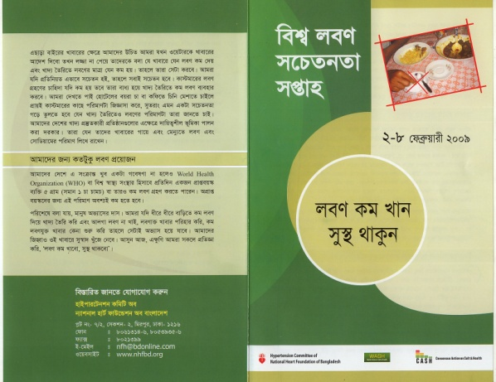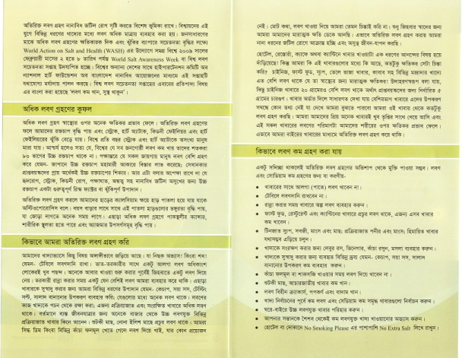

Brochure

4. Discussion programme on National Television and Radio:

Talk shows on salt and health comprising off experts like cardiologists and renowned physicians

were arranged and aired on several national TV’s and Radio channels.

5. Programme on the eve of WSAW 2009 in different districts of Bangladesh:

Different affiliated bodies of National Heart Foundation of Bangladesh organized different

programmes on the eve of WSAW 2009 like miking, leaflet distribution, general awareness meeting etc.

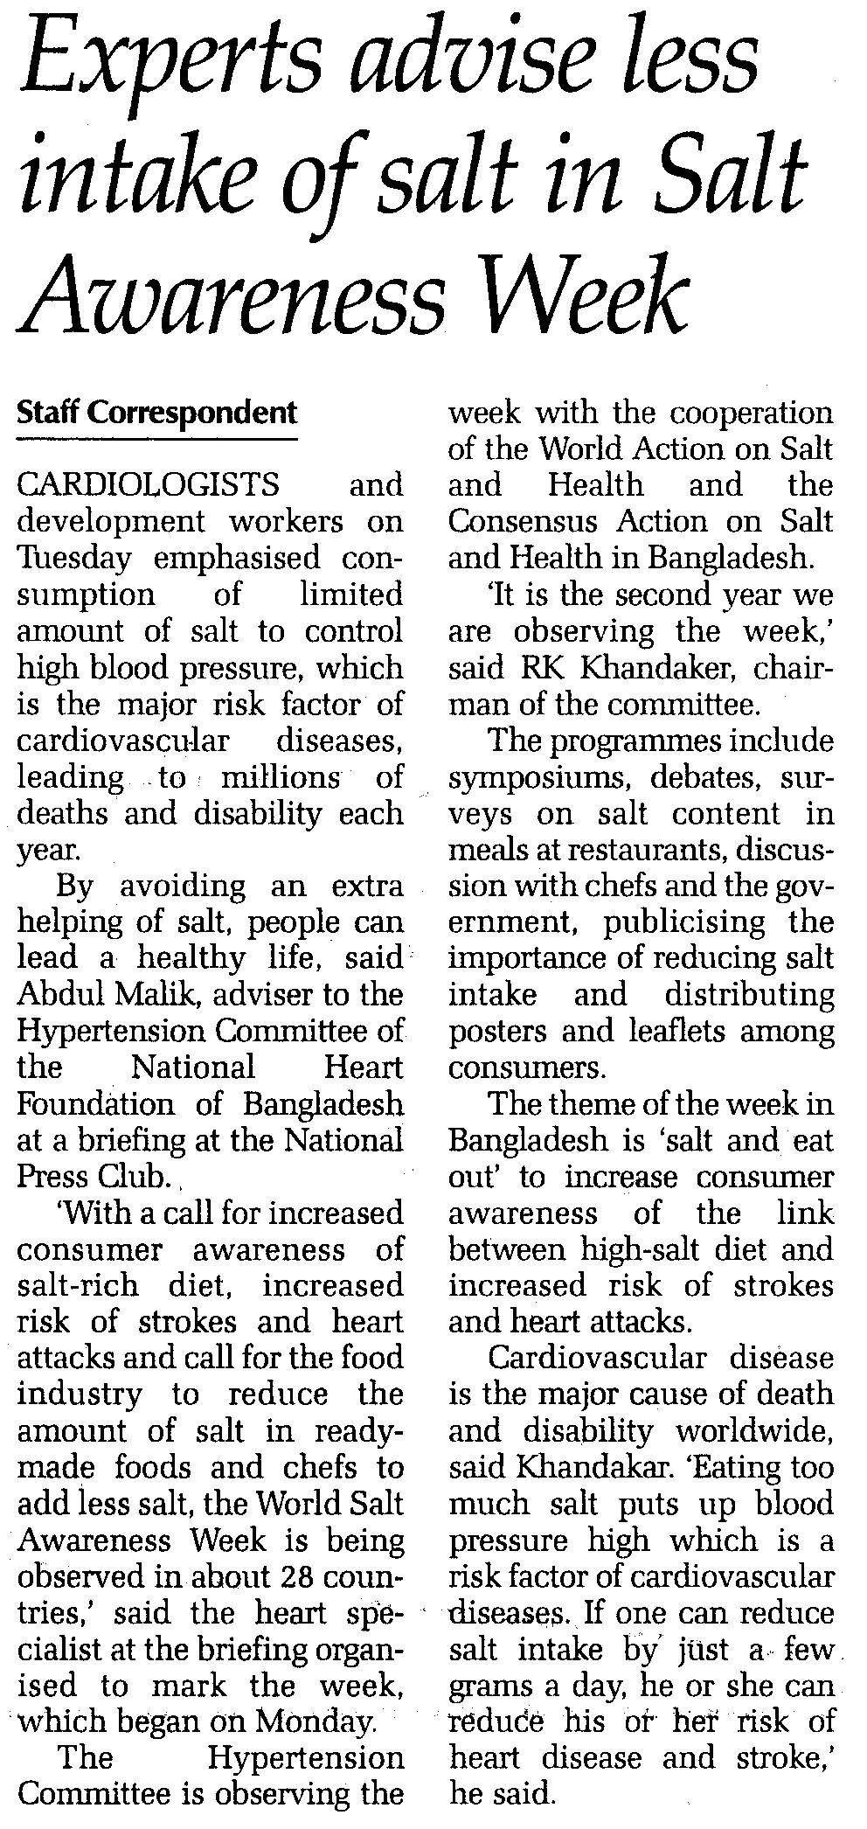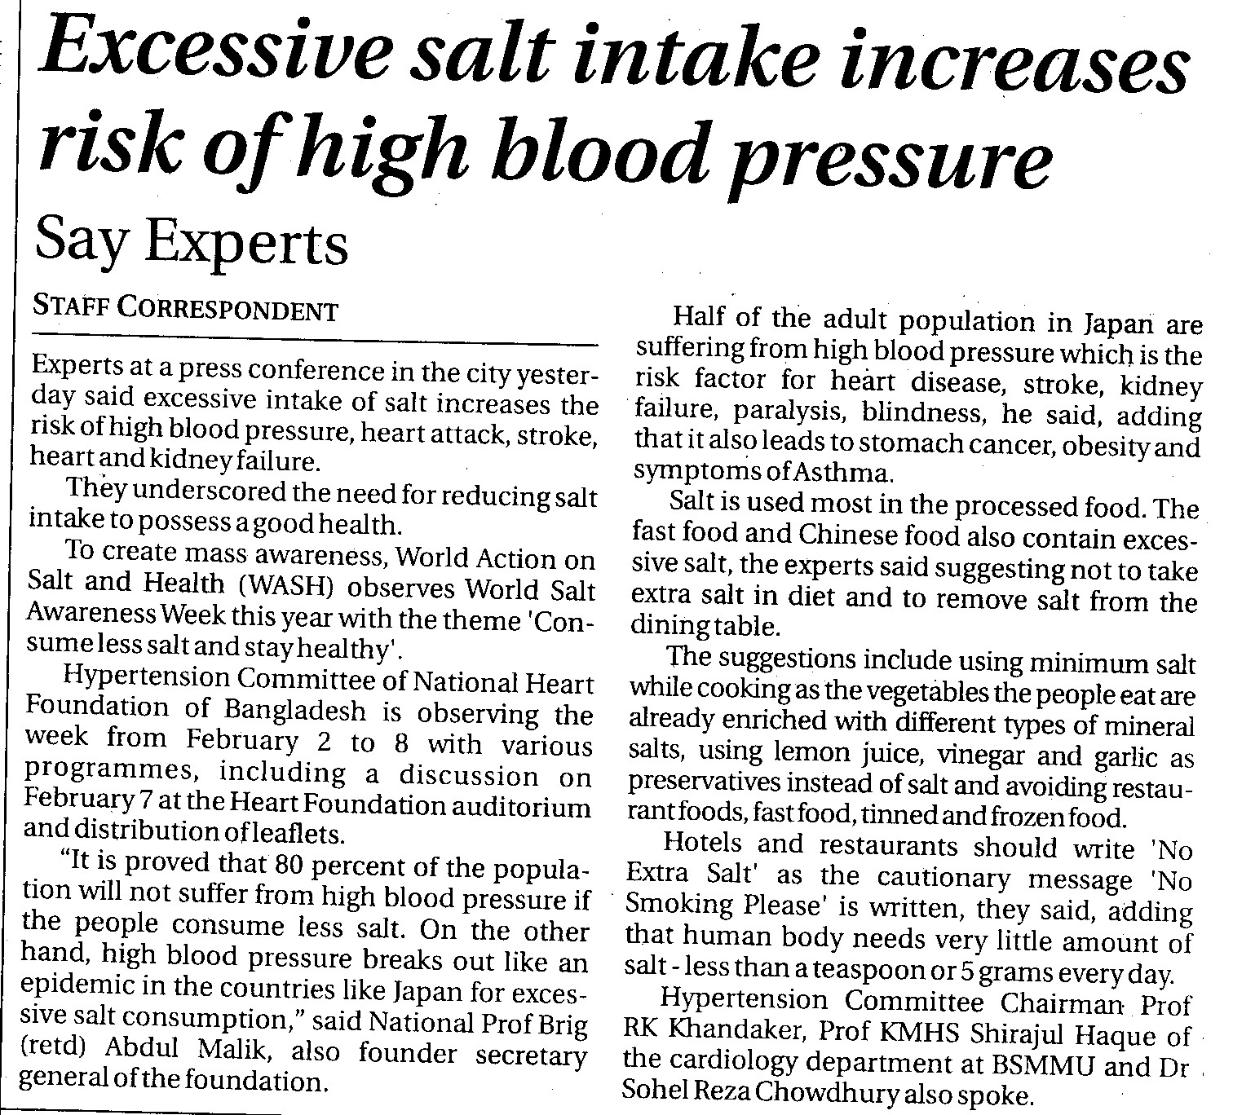

Major achievements:
The observance of World Salt Awareness Week 2009 by Hypertension Committee of National Heart Foundation of Bangladesh had very important contribution in raising the awareness about prevention of cardiovascular diseases in Bangladesh. It was widely discussed in the most of the national dailies. We believe observance of this week regularly will greatly contribute to the prevention and control of cardiovascular diseases.

Recommendation and plan for follow up actions:
Regular observance of World Salt Awareness week will be done by the Hypertension Committee of National Heart Foundation of Bangladesh. A request letter will be sent to all the 35,000 doctors and paramedics of whole Bangladesh to take necessary measures to reduce salt intake in community and family level with special emphasis on hypertensive patients, obese population and also to discuss the ill effects of high salt intake with patients’ relatives.

Prof. R. K. Khandaker
Vice President, National Heart Foundation of Bangladesh
Chairman, Hypertension Committee of National Heart Foundation of Bangladesh
Member, WASH and ISH

